**Nexus Aquarium**

*Developer Guide*

|  |  |  |
| --- | --- | --- |
| **Supervisor.** | **Sir HASSAN NADEEM** | |
| **Batch.** | **2206C1** | |
| **Group.** | B | |
| **Serial No.** | **Enrollment Number** | **Student Name** |
| 1. |  | JAMILA MUGHAL |
| 2. | 123456 | MARYAM NADEEM |
| 3. | 123456 | MUHAMMAD SUMMAID SIDDIQUI |
| 4. | 123456 | SHEHERYAR KHAN KUNDI |

1. **Home** (*index (1).html*)

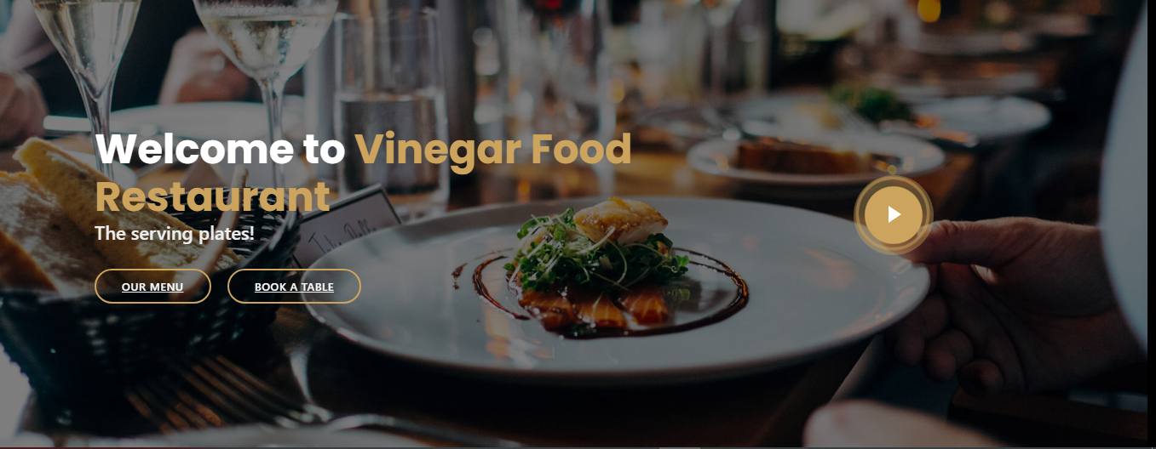

***Figure 1: Home page to Vinegar Food RESTAURANT***

 Our Slogan has given to the peoples toward our website. “DIVE TO THE DEPTHS OF THE OCEANS WITH US”.

* By clicking (**Get started**) button user while redirect to the main webpage.

**Code of Home page**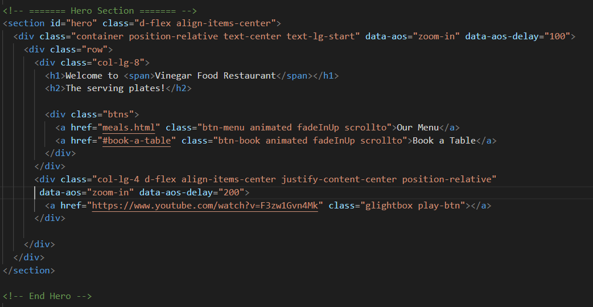

1. **Navbar (navbar.html)**

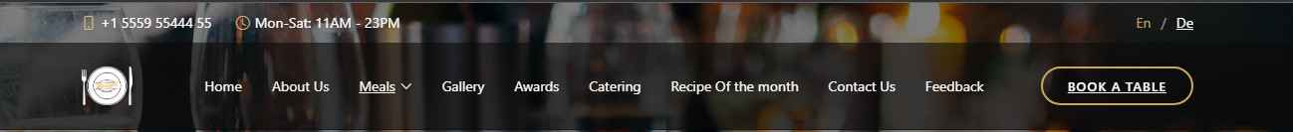

***Figure 2: Navbar***

We have given seven essentials. By clicking any of the essential’s and redirect to the linked page. (0. index (1).html)

**Code of Navbar**

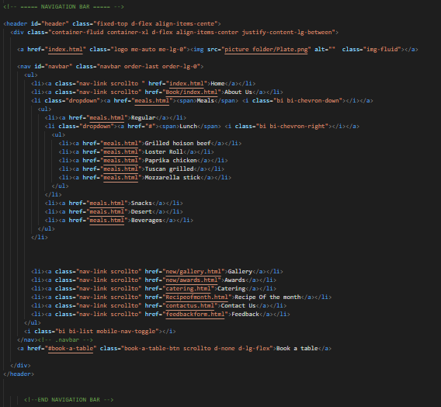

1. **About us (index.html)**



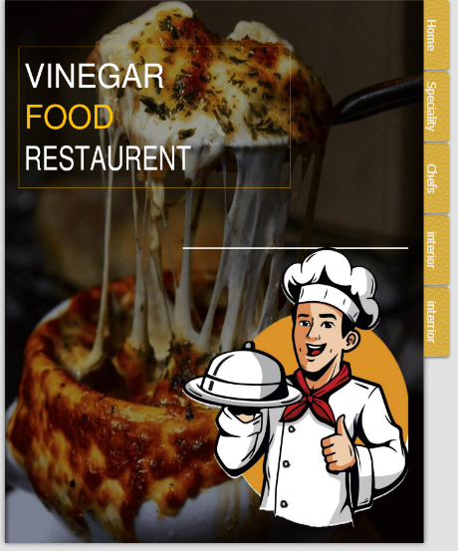

 ***Figure 3: About us***

**

* Explore different habitats, from the sweltering tropics to tidal rock pools.*

* Discover all about our weird and wonderful creatures with fun and interactive learning experience.*

***Code of About Us***

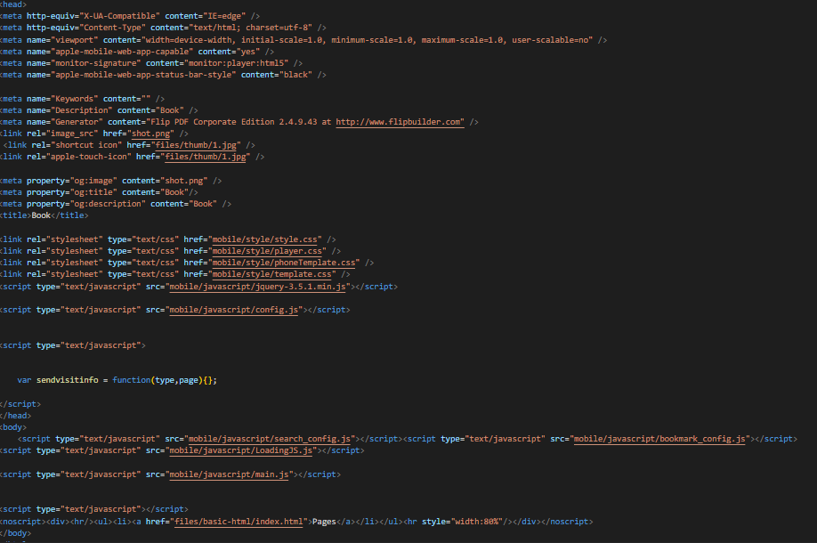

**Service (index (1).html)**

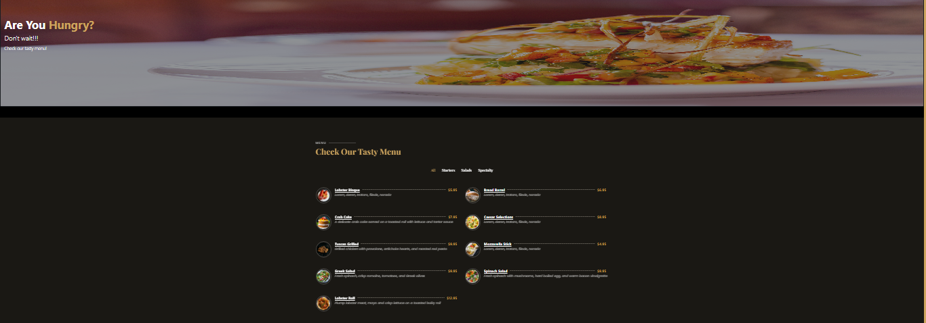

***Figure 4: MEALS***

*We have mentioned our basic services to make people known about the service we provide.*

** ***Home based restaurant:*** *On our first service we have mentioned about providing home-based aquarium and providing them oceanic environment.*

* ***About us:*** *We are giving idea about providing oceanic environment at home and we have mentioned how can be treat aquatic pets at home.*
* ***Cleaning Service:*** *We have mentioned that we are providing aquarium home cleaning services to the customer.*
* ***Customer Service:*** *For the ease of the people our website us providing customer service for the customer so that they can contact directly to our aquatic assistant*

***Code of Meals***

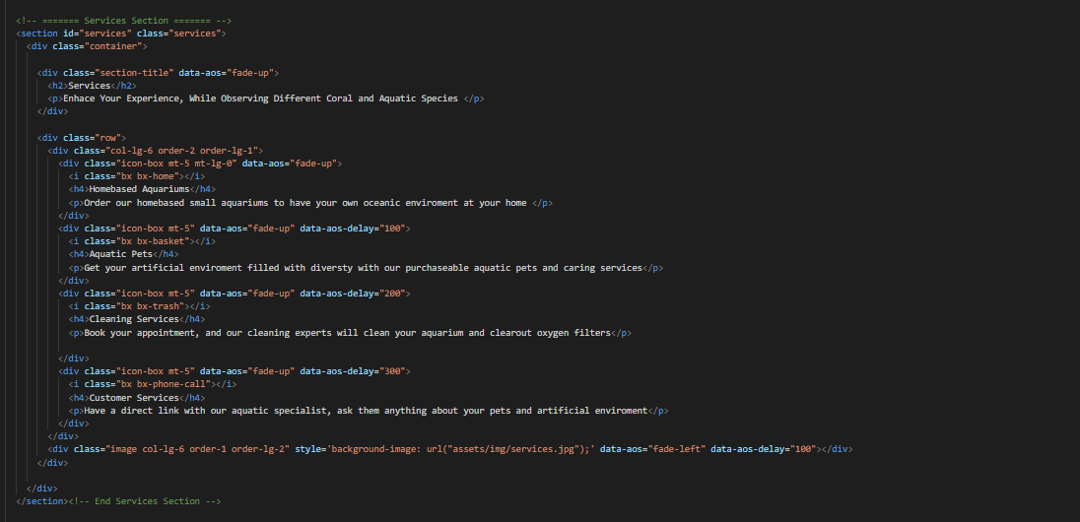

1. ***Gallery (gallery.html)***

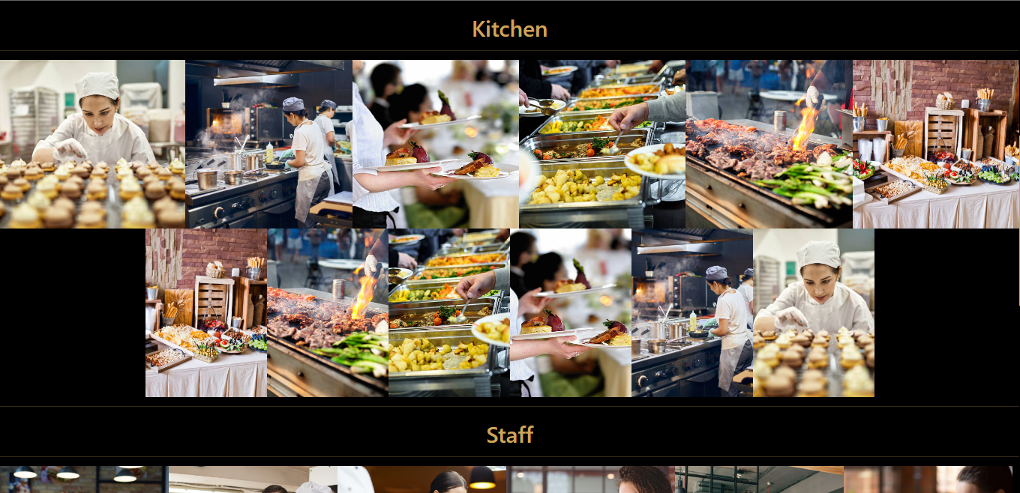



***Figure 5: Gallery***

***Description:*** *Every Aquarium have big tank and mini Aquarium for some unique and small types so species which can’t survive between big kind of marine.*

***“Description of some mini species”***

*We have given some unique kind of species in our mini Aquarium page*

*And provide hover to highlight the name and pictures so that people who are visiting our website can gain knowledge.*

* ***Mickey Mouse Platy***
* ***Guppies***
* ***Neon Tetra***
* ***Gold Barb***

***Code of Gallery***

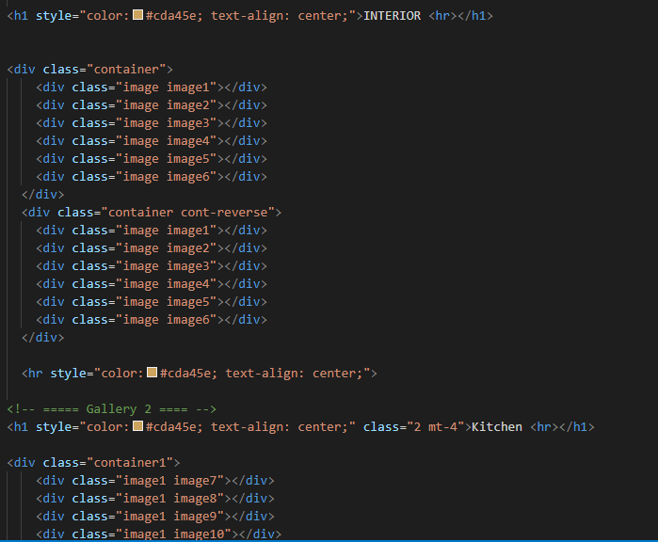

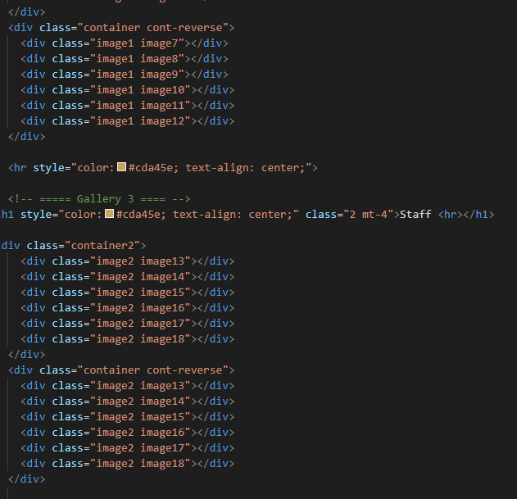

1. ***Menu bar:***

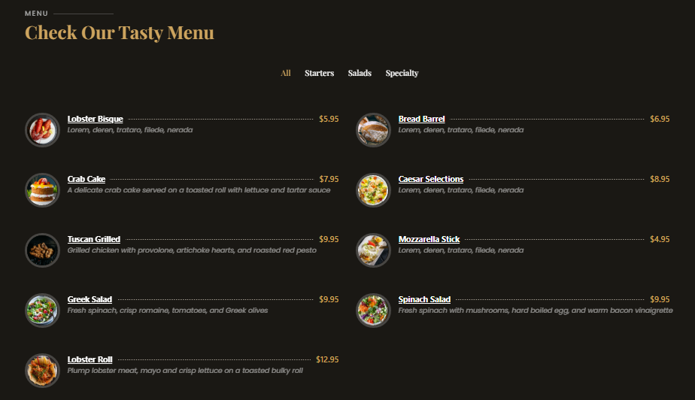

***Figure 6: Description of our Menu bar***

***Use to load the remaining sections. The following is a list of those sections:***

*As we have work on only single page and re-directing on other sections. So we are made our web directed pages.*

* ***Home Page (1. index (1).html)***
* ***About Page (2. index (1).html- About Section)***
* ***Services Page (3. index (1).html-Services Section)***
* ***Portfolio Page (4. index (1).html-Portfolio Section)***

*Portfolio details(5.Portfolio-detail.html)*

*Portfolio details(6.Portfolio-details-2.html)*

*Portfolio details(7.Portfolio-details-3.html)*

*Portfolio details(8.Portfolio-details-4.html)*

*Portfolio details(9.Portfolio-details-5.html)*

*Portfolio details(10.Octopus-details.html)*

*Portfolio details(11.Jellyfish-details.html)*

*Portfolio details(12.Beluga-details.html)*

*Portfolio details(13.Penguine-details.html)*

* ***Dine Inn Page (14. index (1).html)***
* ***Visit Page (15. index (1).html)***
* ***Contact Page (16. index (1).html***

1. ***Our Restaurant Video:***

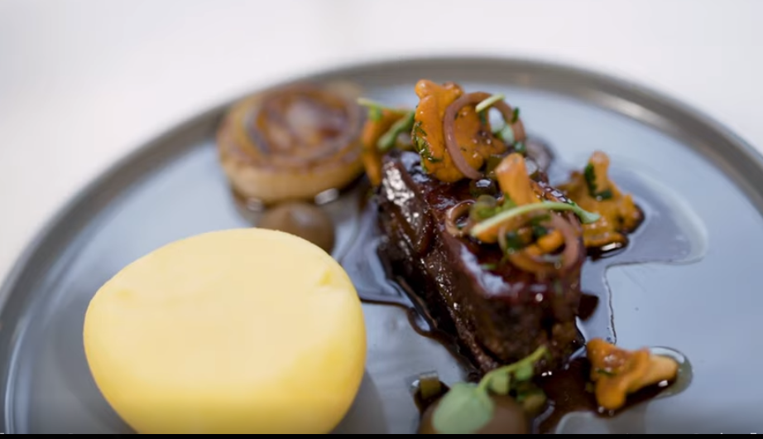

***Figure 7: Linked Video***

***We have put our Restaurant survey video link from YouTube for the attraction of client.***

***Code of Linked Video***

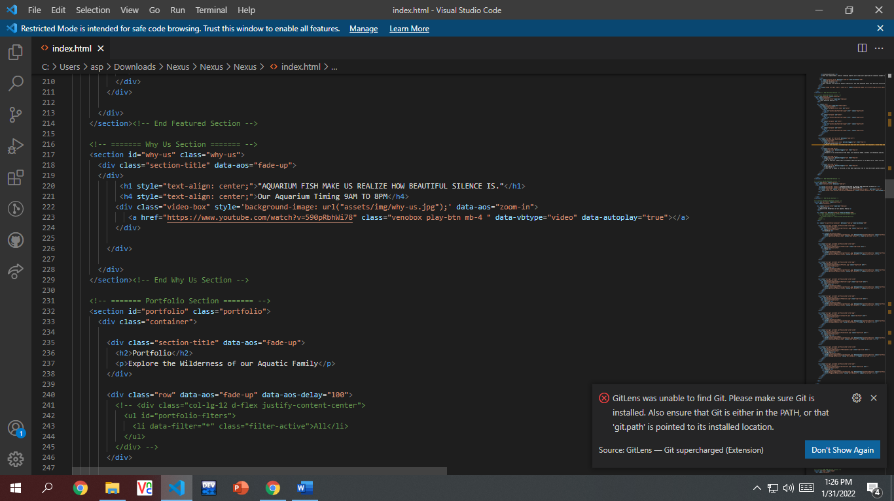

1. ***Portfolio (index (1).html):***

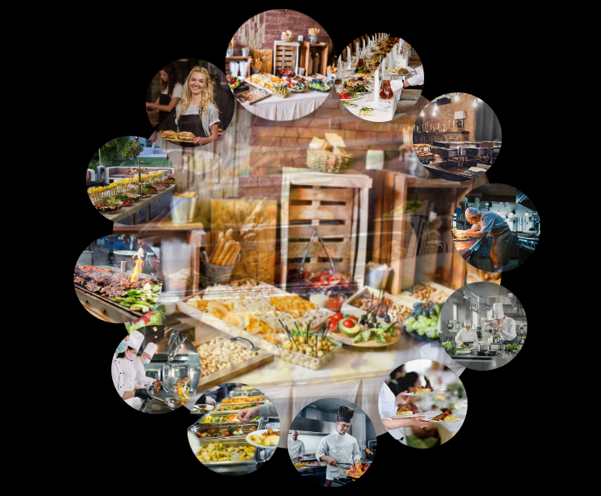

***Figure 8: Portfolio***

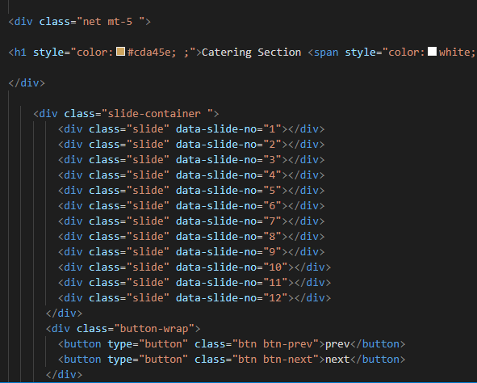

1. ***Contact (index (1).html):***

***Figure 13: Contact***

*In our contact section we have given location map for the ease of the people*

*Email id and phone number for contacting in case of any problem.*

*Feedback Form:*

*To know the response of the people our team has given feedback page for the ideas and feedback of the people.*

***Code of Contact***

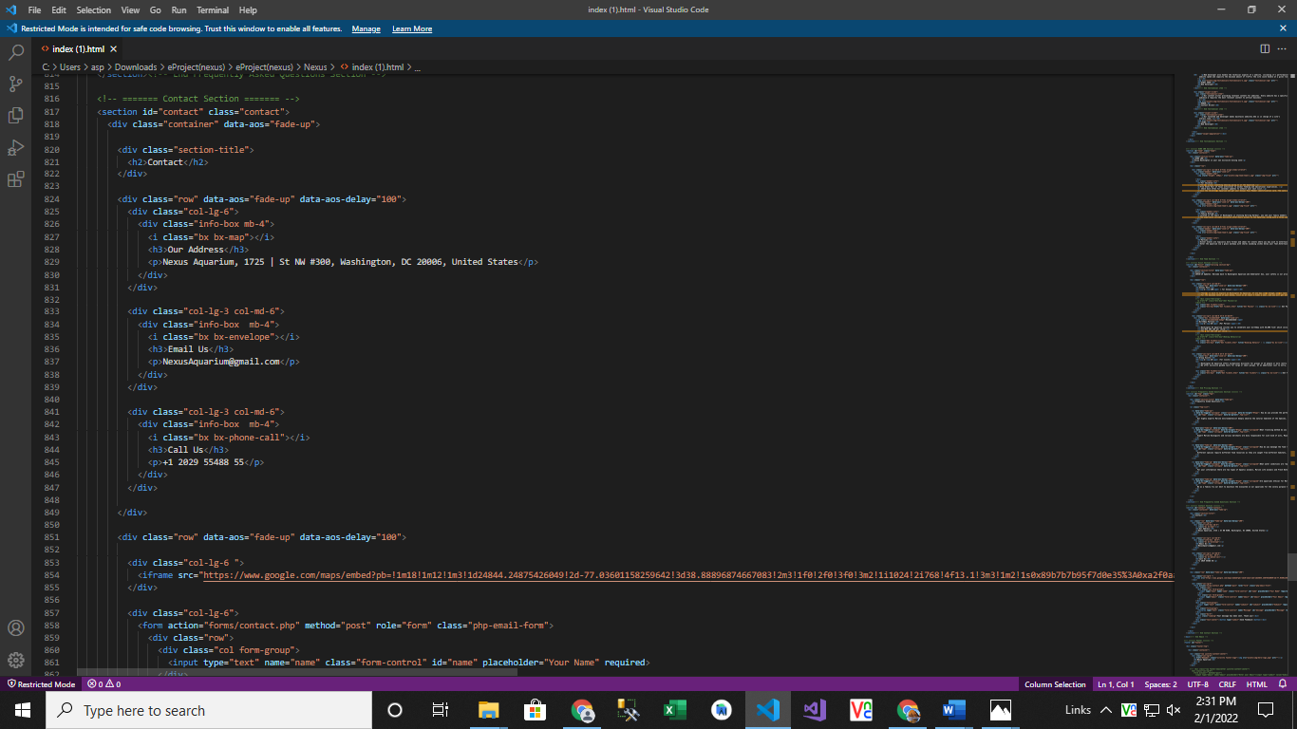

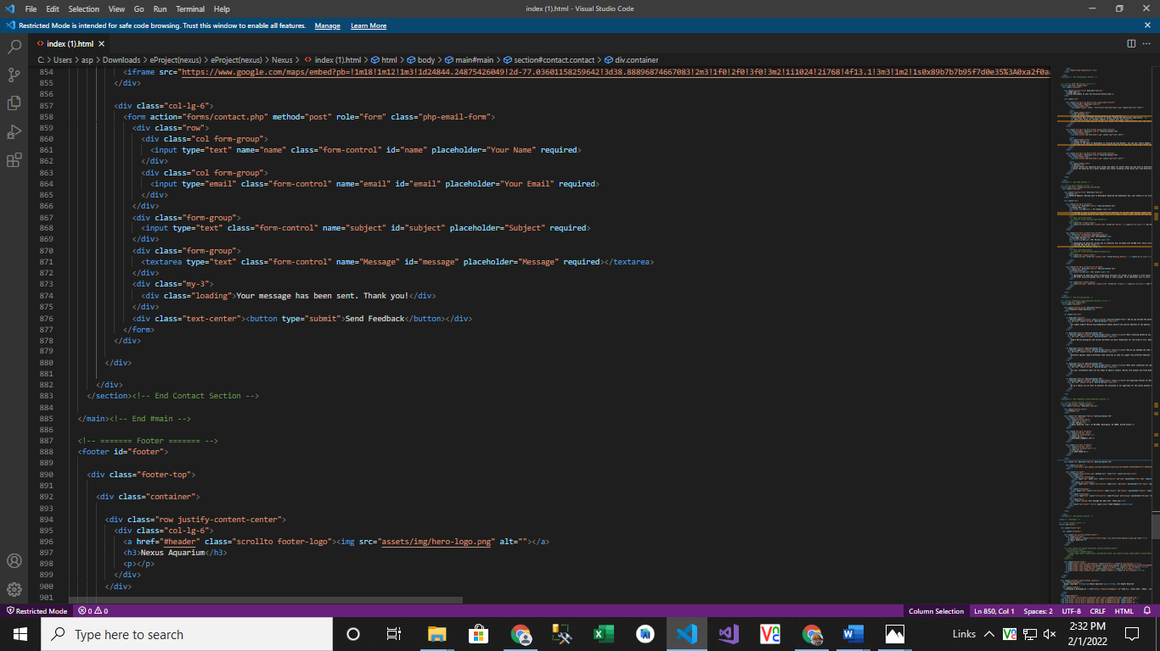

1. ***Inner Page(inner.html):***

***Figure 14: Footer***

  <!--======= footer section ======= -->

        <div class="card bg-dark mt-5 pt-4" style="text-align:center; color:white" >

          <div class="card-body" style="width:100%;">

              <img src="picture folder/Plate.png"  style="height:95px; " alt="">

            <h5 class="card-title mt-3 " >Vinegar <span style="color: #cda45e;"> Food </span>Resturent</h5>

            <p class="card-text" >Vinegar food resturent, a perfect place to rejoice variety of cuisines<br/>

              with your love ones, to soak in the relaxing decor & desire to revisit for once is never enough! <br/> For any

               complain or queries kindly call <span style="color: #cda45e;">111-444-111</span>

                <br/> or send us a mail at <span style="color: #cda45e;">marketing@kababjees.com</span></p>

                <div class="container text-center" style="border-top: 1px solid white ;">

                  <div class="row">

                    <div class="col col-12 mt-4">

                      Designed & Developed by <span style="color: #cda45e;"> Batch 2206C1</span>

                    </div>

                    </div>

                    </div>

          </div>

        </div>

<!-- End footer section -->